



CHALLENGE NAME : **[The _Invisible _Date ]**

DEV : **[ Manjiree Sanap]**

CATEGORY : **[ OSINT]**

LEVEL : **[Easy ]**







**2024**

 

CHallenge Name :**[The _Invisible _Date ]**

DEV : [ ] 1

**Question:** A certain book titled ‘Sell to Serve’ by an author has recently gained attention. The author is known for unique social media post discussing things that money can’t buy. Your task is to uncover the date of that social media post.

**1**

**Description:**

1.Start by searching for the Instagram profile of the author of ‘Sell to Serve’.

2. Analyze the posts until you find one discussing “things money can’t buy.”

3. Check the date of that specific post, noting it in the format **‘YYYY-MM-DD’**

Once you find the post, extract the date which should be’2023-10-15’. This is the correct answer to the challenge. The flag should be formatted as **‘RecruitmentCTF{2023-10-15}’**.

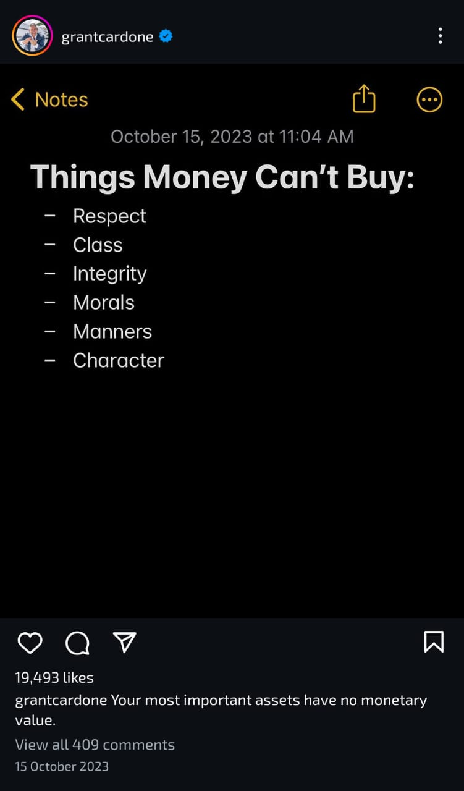

DEV : [ Manjiree Sanap]